1. Mockup
   * + Main Page  
       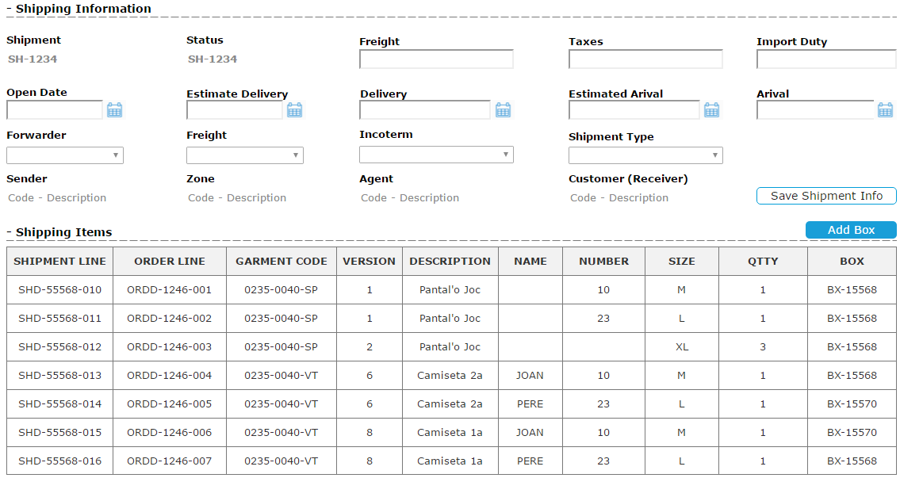
     + Add Box
       - Manipulation  
         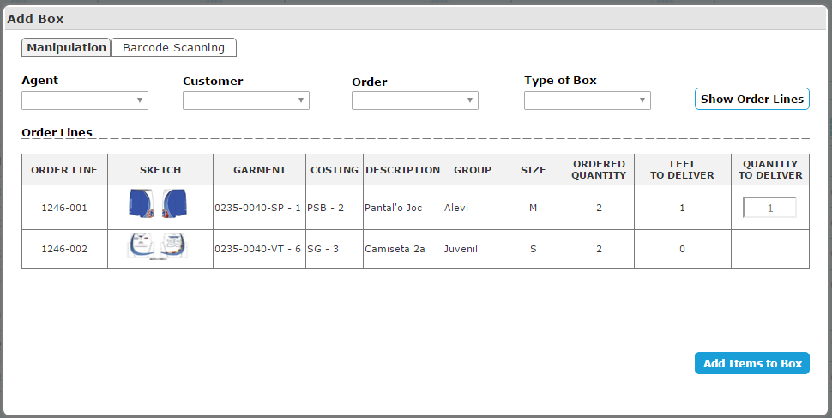
       - Barcode Scanning  
         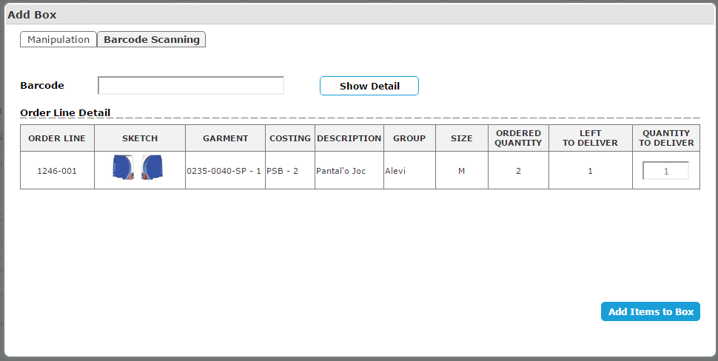
2. Business
   * Filtering options:
   * Factory View
   * Zone View
   * Agent View
   * Customer View
   * Test